Dockboards of Walking-Working Surfaces Training Material and Comprehension Quiz

- Policy
  - Romero’s Food Products Inc. ensures that dockboards can withstand the maximum load for each walking-working surface. Ensure that the capacity of the dockboard is clearly identified.
  - Dockboards are designed, constructed, and maintained in such a way that they do not allow transfer vehicles to run off the dockboard's edge. When there is no danger of transfer vehicles running off the dockboard edge, dockboards that do not have run-off protection may be used.
  - Portable dockboards are secured by anchoring them in place or using equipment or devices that prevent the dockboard from moving out of a safe position. When securing the dockboard is not possible, the employer ensures that the dockboard makes adequate contact with the surface to prevent it from moving out of a safe position.
  - Measures, such as wheel chocks or sandshoes, are used to prevent the transport vehicle (e.g., a truck, semi-trailer, trailer, or rail car) on which a dockboard is placed from moving while employees are on the dockboard.
  - The management ensures that portable dockboards are equipped with handholds or other devices that facilitate dockboard handling safely.

- Procedure
  - Dockboard Design Features
    - Side curbs for run-off protection
    - A mechanism for securing an object to prevent it from moving out of a secure position, such as locking legs. Span locks are required for big gaps in which the locking leg does not completely immobilize the dockboard.
    - A feature that enables secure handling, such as handholds or forklift lifting eyes/chain.
  - Dockboard Pre-Use Requirements
    - Read and understand the manufacturer’s instruction.
    - Inspect the dockboard and check the following:
      - Manufacture serial plate with the capacity available and legible.
      - Damage may cause injury while handling or using the dockboard, such as sharp edges, burrs, cracks, and broken welds.
      - All nuts and bolts are not lost or missing.
      - Side curbs are present and secure.
      - Locking legs are in place and secure.
      - Casters/wheels (if equipped) are in good condition and secure.
      - Span locks (if equipped and when required) are in good condition.
      - Lifting handles for manual lifting or lifting eyes/chains for forklift use are in good condition and secure.
      - All surfaces are clean and free of oil/dirt build-up.
    - If there are findings in the inspection, remove the dockboard from the service and report it to immediate supervisor.
  - Dockboards Safety
    - Use dockboards only when wheel chocks or trailer restraints, also known as dock locks and truck restraints, are available and used.
    - Ensure that the dockboard capacity is sufficient. Consider the weight of the loads and the personnel and material handling equipment, such as forklifts. The intended load may not exceed the dockboards' capacity.
    - Before installing dockboards, use wheel chocks or trailer restraints.
    - Wear proper personal protective equipment such as protective shoes and gloves.
    - Practice proper lifting techniques when manually handling dockboards. Utilize the handholds and seek assistance if necessary.
    - When applicable, ensure that only certified powered industrial vehicle operators use the lifting eyes to move the dockboard.
    - Ensure dockboard will not shift when in use. Check if:
      - The length of the locking leg is greater than the space between the vehicle and the loading dock for short gaps.
      - The locking leg is positioned against the vehicle's rear, and the span locks are positioned against the loading dock edge for large gaps.
    - Ensure the dockboard is centered when in use.
    - Once completed, remove the dockboard using the appropriate lifting techniques (handholds) or lifting aids (forklifts).
    - Return the dockboard to its proper storage place (as far away from egress paths, exits, and work areas as possible).
  - Illustrations
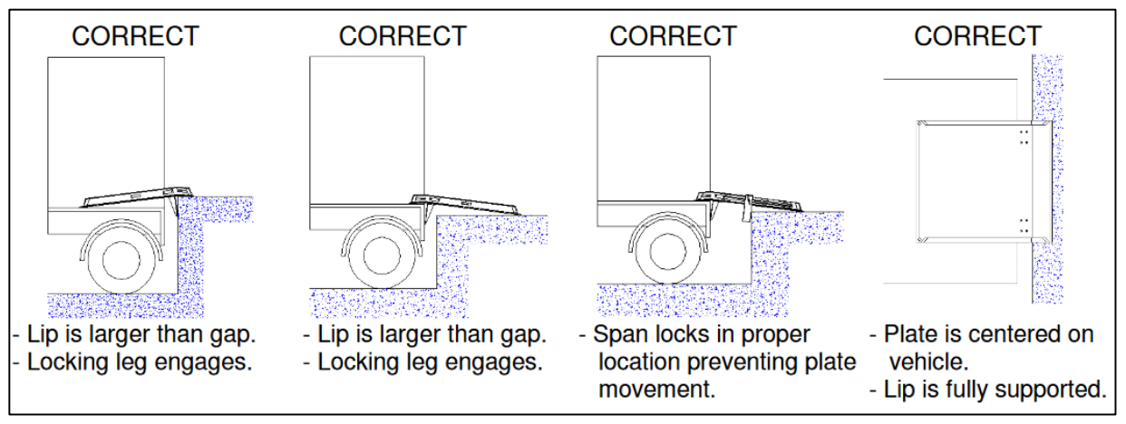
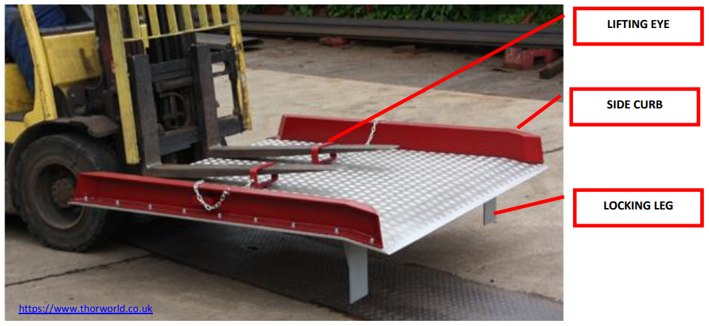
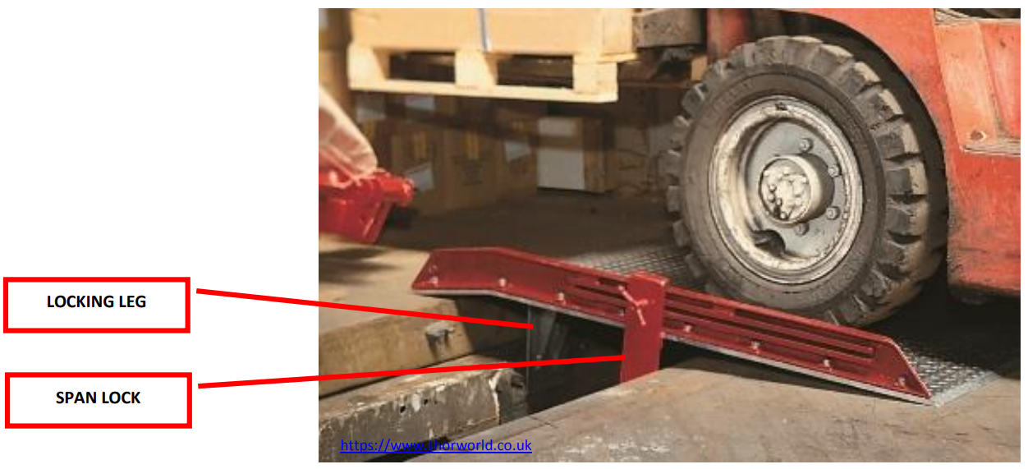
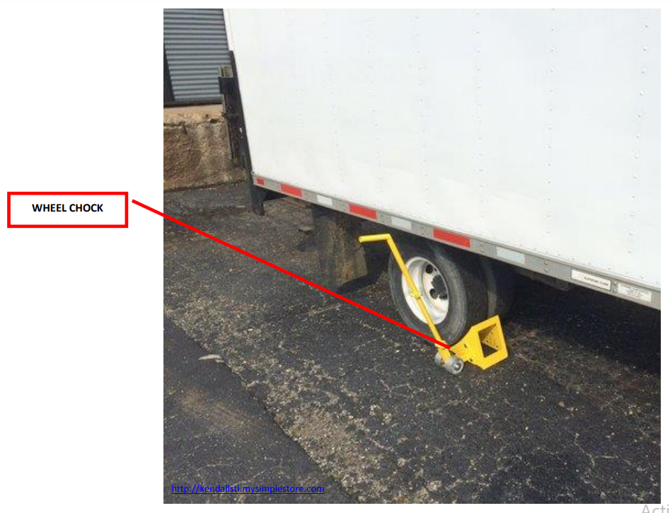
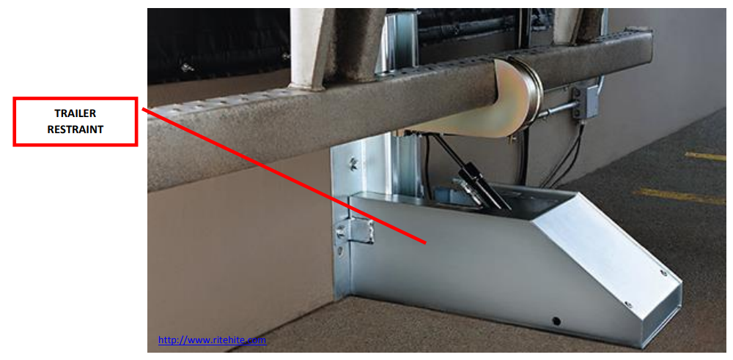

- Responsibility
  - Senior Management
    - Ensure that employees are trained on the dockboard safety requirements prior to their use.
  - Employee/User
    - Obtain and understand manufacturer instructions.
    - Report incidents and equipment concerns to supervisors immediately.
- Corrective Action
  - If any inspection findings are detected, immediately withdraw the dockboard from service and notify the supervisor.
  - Retrain staff when deficiencies in the user's understanding or use of dockboards are detected or when workplace changes render earlier training obsolete or insufficient.

- Review - Quality
  - Review if dockboards are inspected prior to use.
  - Review and update this program at least annually.

- History
Revision No.: | Revision Date: | Description of Change: | Originator / Author Name: | Title / Department:
0 | 20220902 | Original | Arnel Ryan | PCQI / Compliance
1 | 20231207 | - Aligned with the updated program.  - Updated the Policy, Procedure, and Responsibility.  - Added Comprehension Quiz: ANSWER KEY. | Arnel Ryan | PCQI / Compliance
2 | 20241005 | - Change the title part from Lesson to Training Material and Comprehension Quiz  - Changed email from services@consultareinc.com to rfp@consultareinc.com  - Updated Review to Review-Quality | Arnel Ryan | PCQI / Compliance

Requirements:
- The trainee has read or received a verbal translation of all or part of the policy, procedure, method, and or SOP for which they are being trained.
- The trainee has demonstrated the task they are to perform or the procedure for which they are being trained as required.
- The trainee has demonstrated the ability to perform the task with acceptable proficiency and with minimal supervision as required.

TRAINEE (Print Name): | TRAINEE (Signature): | Date: | Department:
Trainer / Supervisor (Print Name): | Trainer (Signature): | Date: | Department:

UPON COMPLETION – EMAIL TO rfp@consultareinc.com

NAME (Print): | Date:

Dockboards of Walking-Working Surfaces Comprehension Quiz

Direction: Choose the best answer and encircle the letter.

- Practice proper lifting techniques when manually handling dockboards. Utilize the handholds and seek assistance if necessary.
  - True
  - False

- Who is responsible for reporting incidents and equipment concerns to supervisors immediately?
  - Employer
  - Employee
  - Supervisor

- Who is responsible for ensuring that employees are trained on the dockboard safety requirements before use?
  - Senior Management
  - Employee
  - Employer

- The management ensures that portable dockboards are equipped with handholds or other devices that facilitate dockboard handling safely.
  - True
  - False

- Who will be notified if any inspection findings are detected to immediately withdraw the dockboard from service?
  - Supervisor
  - Employer
  - Employee

UPON COMPLETION – EMAIL TO rfp@consultareinc.com

